Department of Mechanical & Aerospace Engineering

ME524 – Group Project Abroad

DEVELOPMENT OF AN ELEVATOR PROTOTYPE
INCORPOATING EUROPEAN STANDARDS FOR ELEVATORS INTO DESIGN

Project Supervisor:
Jose Manual Sierra Velasco
jmsierra@uniovi.es

Michael Clarke

January 2015

Nomenclature

Letters:
A – Area [m²]
F – Force [N]
p – Power [W]
P – Pressure [MPa]
R – Radius [m]

Greek letters:
ρ – density [kg/m³]

Acronyms and abbreviations:
2D – acronym for 2-dimensional
3D – acronym for 3-dimensional
CAD – computer-aided design
FEA – finite element analysis
STL – abbreviation for (STereoLithography)

Units: (alphabetise)
kg/m³ – Kilogram per cubic metre
kPa – kilopascals
m – metres
m² – metres squared
m/s – metres per second
m²/s² – metres squared per second squared
MPa – megapascals
N – Newtons
Pa – Pascals
s – seconds
W – Watts
g – grams
kg – kilograms
mm – millimetres

Contents
1 European standards 4
1.1 Design and installation standards 4
1.1.1 Deflection tests 4
1.1.2 Wire ropes 6
1.1.3 Safety precautions and safety gear 6
1.1.4 Braking system 9
1.1.5 Cabin dimensions, maximum load and number of passengers 12
1.2 Accessibility standards 14

1 European standards

1.1 Design and installation standards

The need for standards in modern society is clear; standardization has helped to ensure that products are safe and reliable for the consumer and has benefited business by encouraging innovation, opening up market access and increasing awareness of technical developments [1].

Based on the specification of the lift delivered to the group by the client, it was important that safety was taken into consideration when creating the design. As the group were not particularly knowledgeable with regards to lift design, the EU standards for lifts were investigated during the research stage outlined in the Gantt chart in the Project Management Report.

For the design of the second lift prototype the 2011 EN81-20 EU standards were consulted. These standards contained safety rules for the design and installation of lifts, specifically passenger and goods lifts.

They highlighted all the design parameters needed to make a functioning and legal lift, as well as everything that was not allowed in the design on grounds of safety. In particular they focused on:

- Minimum allowable strength of the lift car’s walls, doors and floor panels. The strength of the lift well’s walls and landing doors was also outlined.
- Safety information regarding wire ropes and suspension of the lift car.
- Precautions against free fall, excessive speed, unintended car movements and creeping of the car. Essentially outlining the necessary safety gear to be included in design.
- Information about braking systems.
- Minimum and maximum dimensions for the lift car as well as information on load area, rated load and number of passengers.

The standards were useful in shaping the overall design of the lift prototype. They also allowed for much more detailed analysis of the design, through research of several different safety gear and application of deflection tests.

1.1.1 Deflection tests

After the concept design stage the materials for each part of the lift were investigated. As availability and lightness were the most important factors when choosing the materials, aluminium alloy 6082 was chosen fro the cabin. After this, the parts were created in SolidWorks.

After the lift cabin was drawn within SolidWorks, a strength analysis was undertaken. This consisted of deflection tests for the cabin panels.

In order to test the strength of the cabin, SolidWorks simulation was used to apply deflection tests to the structure. The EU standards contain deflection tests designed to evaluate the strength of the cabin structure. An example of such a test is given below:

“5.4.3.2.2 Each wall of the car shall have a mechanical strength such that:

a) When a force of 300 N, being evenly distributed over an area of 5 cm² in round or square section, is applied at right angles to the wall at any point from the inside of the car towards the outside, it shall resist without:
- Any permanent deformation (e.g. less than 1 mm);
- Elastic deformation greater than 15 mm.”

The first criteria for the mechanical strength of the cabin was first looked at; the pressure was calculated using the following equation:

$P=\frac{F}{A}$ (1)

Using the force and area provided in the standards i.e. 300 N and 5 cm², the pressure value of 600 kPa was found.

This was applied over an area of 5 mm² as the prototype was scaled down to 1/10 the size of a real lift.

According to the first criteria, each panel of the cabin should be tested under a load of 600 kPa applied at any point on the panel from the inside face. For the prototype cabin the pressure was applied at the point predicted to generate the largest deflection under load. An example of one of the chosen load sites is shown in the figure below:

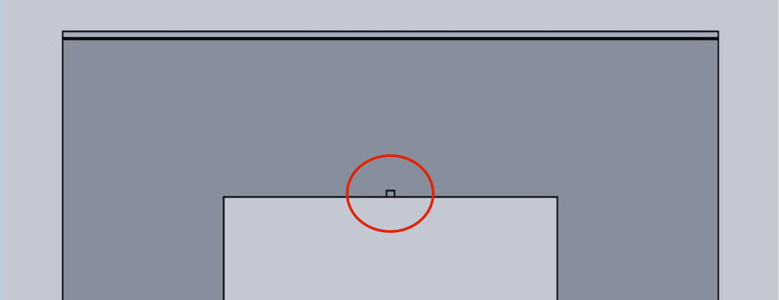
Figure 1: Front face of cabin showing loaded area.

This area, circled in red, was predicted to give the highest deflection under 600 kPa of load. Fixtures were applied to the outside edges of the panel in order to mimic the cabin’s frame structure, therefore the area closer to the door was predicted to deform to a greater degree.

1.1.2 Wire ropes

In order to suspend the lift cabin counterweight, steel wire ropes were needed. This being said, they are not only used to suspend and move the lift; multiple steel wire ropes are used in tandem as an initial safety precaution, should one of them fail. The minimum amount of ropes allowed in the safety standards is listed as 2 [5.5.1.3].

The lift drive type was also specified at this time. From the choices of hydraulic and traction elevators. Traction elevators are driven by drive sheaves. Traction is provided to the ropes by the grip of the guiding grooves in the sheave, hence the name.

Traction drive was chosen for the elevator prototype. This was because traction drive elevators have proven to be more versatile with a greater range of motion than hydraulic drive elevators. The safety standards state that traction elevators may be suspended by steel wire ropes, steel chains with parallel links (Galle type) or roller chains. Steel wires were chosen for the prototype due to their availability and ease of analysis compared to the other options.

The following regulation was given for traction drive elevators:

“5.5.2.2 The safety factor of the suspension ropes shall not be less than:

- 12 in the case of traction drive with three ropes or more;

… The safety factor is the ratio between the minimum breaking load, in Newtons, of one rope and the maximum force, in Newtons, in this rope, when the car is stationary at the lowest landing, with its rated load.”

Therefore a safety factor of 12 was needed for the wire ropes. This allowed for the diameter of steel wire to be calculated and the acquisition of the rope from a local hardware outlet.

1.1.3 Safety precautions and safety gear

A large part of the EN81-20 safety standards are dedicated to precautions against free fall, excessive speed, unintended car movements and creeping of the lift car. These precautions indicate hazardous situations that the lift cabin or counterweight might encounter. To protect against these situations, safety gear is used. The following table taken from the safety standards listed the safety gear needed, as well as the means for tripping the safety gear, for a traction elevator.
Table 1
Protection means for traction and positive drive lifts
Hazardous situation | Protection means | Tripping means
Free fall and excessive speed in down direction of car | Safety gear  (5.6.2.1) | Overspeed governor (5.6.2.2.1)
Free fall of counterweight or balancing weight in the case of  5.2.5.4 a) | Safety gear  (5.6.2.1) | Overspeed governor (5.6.2.2.1) or for rated speeds not exceeding 1 m/s  - tripping by breakage of suspension means (5.6.2.2.2), or  - tripping by safety rope (5.6.2.2.3)
Excessive speed in up direction (traction lifts only) | Ascending car overspeed protection means  (5.6.6) | Included in 5.6.6
Unintended car movement with open doors | Protection against unintended car movement  (5.6.7) | Included in 5.6.7

The definition for safety gear is explained in the safety standards:

“5.6.2.1.1.1 The safety gear shall be capable of operating in the downward direction and capable of stopping a car carrying the rated load, or a counterweight or balancing weight at the tripping speed of the overspeed governor, or if the suspension devices break, by gripping the guide rails, and of holding the car, counterweight or balancing weight there.”

This definition implies individual braking systems integrated into the cabin and counterweight that are applied directly to the guide rails in an emergency. The tripping means for the safety gear is detailed below:

“5.6.2.2.1.1 General provisions

The following shall be satisfied:
a) Tripping of the overspeed governor for the safety gear shall occur at a speed at least equal to 115 % of the rated speed and less than:
1) 0.8 m/s for instantaneous safety gears except for the captive roller type; or
2) 1 m/s for safety gears of the captive roller type; or
3) 1.5 m/s for progressive safety gear used for rated speeds not exceeding 1.0 m/s; or
4) $1.25×v+\frac{0.25}{v}$in metres per second for progressive safety gear for rated speeds exceeding 1.0 m/s.

NOTE For lifts where the rated speed exceeds 1 m/s, it is recommended to choose a tripping speed as close as possible to the value required in 4).”
The safety standards also state the following:

“5.6.2.1.6.4 Safety gears shall not be tripped by devices, which operate electrically, hydraulically or pneumatically.”

As the speed for the lift was chosen to be 1 m/s (scaled down to 0.1m/s for the prototype) the tripping speed for the safety gear could be calculated:

According to the standards, for a lift speed of 1 m/s the tripping speed should be at least 115% of the rated speed, therefore 1.15 m/s. As the rated speed was chosen to be 1 m/s the tripping speed should not exceed 1.5 m/s. Thus the tripping speed should be between 1.15 and 1.5 m/s.

As stated in the interim report [3], the original intention was to include safety gear in the 2nd and 3rd prototypes. The size, weight and strength of all parts were to be applied in accordance with the safety standards, however scaled down to an appropriate size. Some aspects of the safety standards such as ventilation and lighting as well as the cabin skirt, balustrade and buffer were not to be designed into the physical prototypes [appendix???].

Unfortunately the safety gear, defined in 5.6.2.1.1.1, could not be implemented into the prototypes due to time and budget restrictions. The final prototype featured a disk brake coupled alongside the traction sheath. This design allowed the cabin and counterweight to be stopped at the same time in case of an emergency. The brake was controlled electronically and could be activated by the user by requesting the ‘emergency brake’ function. More detailed information regarding the braking system and the electronic activation can be found in 1.1.5.

Normally, to prevent the cabin and counterweight from free fall an overspeed governor is required. This tripping means does not require electricity, hydraulics or pneumatics to activate safety gear. The governor contains weighted hooks that, at the tripping speed of the lift, accelerate outwards and lock due to increasing centripetal force.

This device was considered for the prototype, although it would not be used to trip safety gear, instead it would trip the brake system. However, due to the complexity of the device, as well as scaling problems, it was not used in the physical prototype.

As shown in table 1 there are two more hazardous situations that must be taken into account when designing a traction drive lift: excessive upward speed of the cabin and unwanted movement of the cabin with the doors open.

The protection means for excessive upward speed is detailed in the standards:

“5.6.6.1 The means, comprising speed monitoring and speed reducing elements, shall detect uncontrolled movement of the ascending car at a minimum 115 % of the rated speed, and shall cause the car to stop, or at least reduce its speed to that for which the counterweight buffer is designed.”

More detail is also given about unwanted cabin movement with open doors:

“5.6.7.1 Lifts shall be provided with a means to stop unintended car movement away from the landing with the landing door not in the locked position and the car door not in the closed position, as a result of failure in any single component of the lift machine or drive control system upon which the safe movement of the car depends, except failure of the suspension ropes or chains and the traction sheave or drum or sprockets of the machine, flexible hoses, steel piping and cylinder.”

If a full sized lift were to be built rather than a scaled prototype then all of the necessary safety gear would have been included. However it was not feasible to include all the safety gear with the group’s time and budget limitations.

1.1.4 Braking system

The general provisions given for an elevator braking system are given in the safety standards:

“5.9.2.2.1.1 The lift shall be provided with a braking system, which operates automatically in the event of loss of:

a) The mains power supply;
b) The supply to control circuits.”

The braking system mentioned in this section of the safety standards is independent from the safety gear mentioned previously. Like the safety gear, the braking system stops the lift in an emergency, however it only acts if the supply to power or control systems is lost.

The standards also specify what kind of braking system should be used:

“5.9.2.2.1.2 The braking system shall have an electro-mechanical brake (friction type), but may, in addition, have other braking means (e.g. electric).”

The brake system for the prototype was chosen to be electro-hydraulic i.e. electrically operated and with a hydraulic actuator. The system was made up from the callipers, pads and hydraulic actuation mechanism from a bicycle brake as well as a custom aluminium disk. The following excerpt from the standards allowed for the position of the brake system to be determined.

“5.9.2.2.2.2 The component on which the brake operates shall be coupled to the traction sheave or drum or sprocket by direct and positive mechanical means.”

As mentioned previously the disk brake was coupled alongside the traction sheath. The following figure shows the brake system and it’s positioning relative to the traction sheath on the prototype:

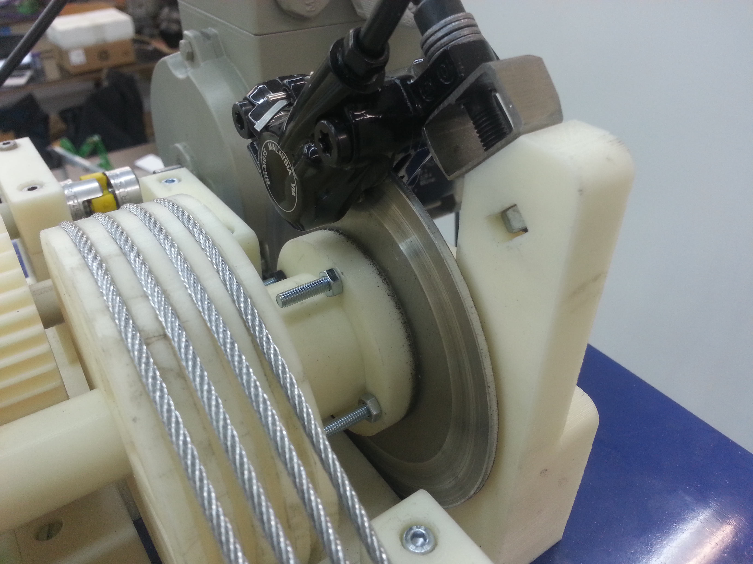
Figure 2: Disk brake positioned in line with the traction sheath.

Though the brake system shared some similarities with the safety gear, the tripping means for these systems differed. The safety gear must be activated by a device like the overspeed governor explained previously. The brake system however is activated differently, as explained in the following extract from the safety standards:

“5.9.2.2.2.3 To hold off the brake, in normal operation, shall require a continuous flow of current.”

The brake on the prototype was controlled electronically and would be activated by request of the user. This braking system would not be legal according to the standards, as it should be activated directly by the loss of current flow.

The mechanism for activating the brake on the prototype is shown in the figure below:

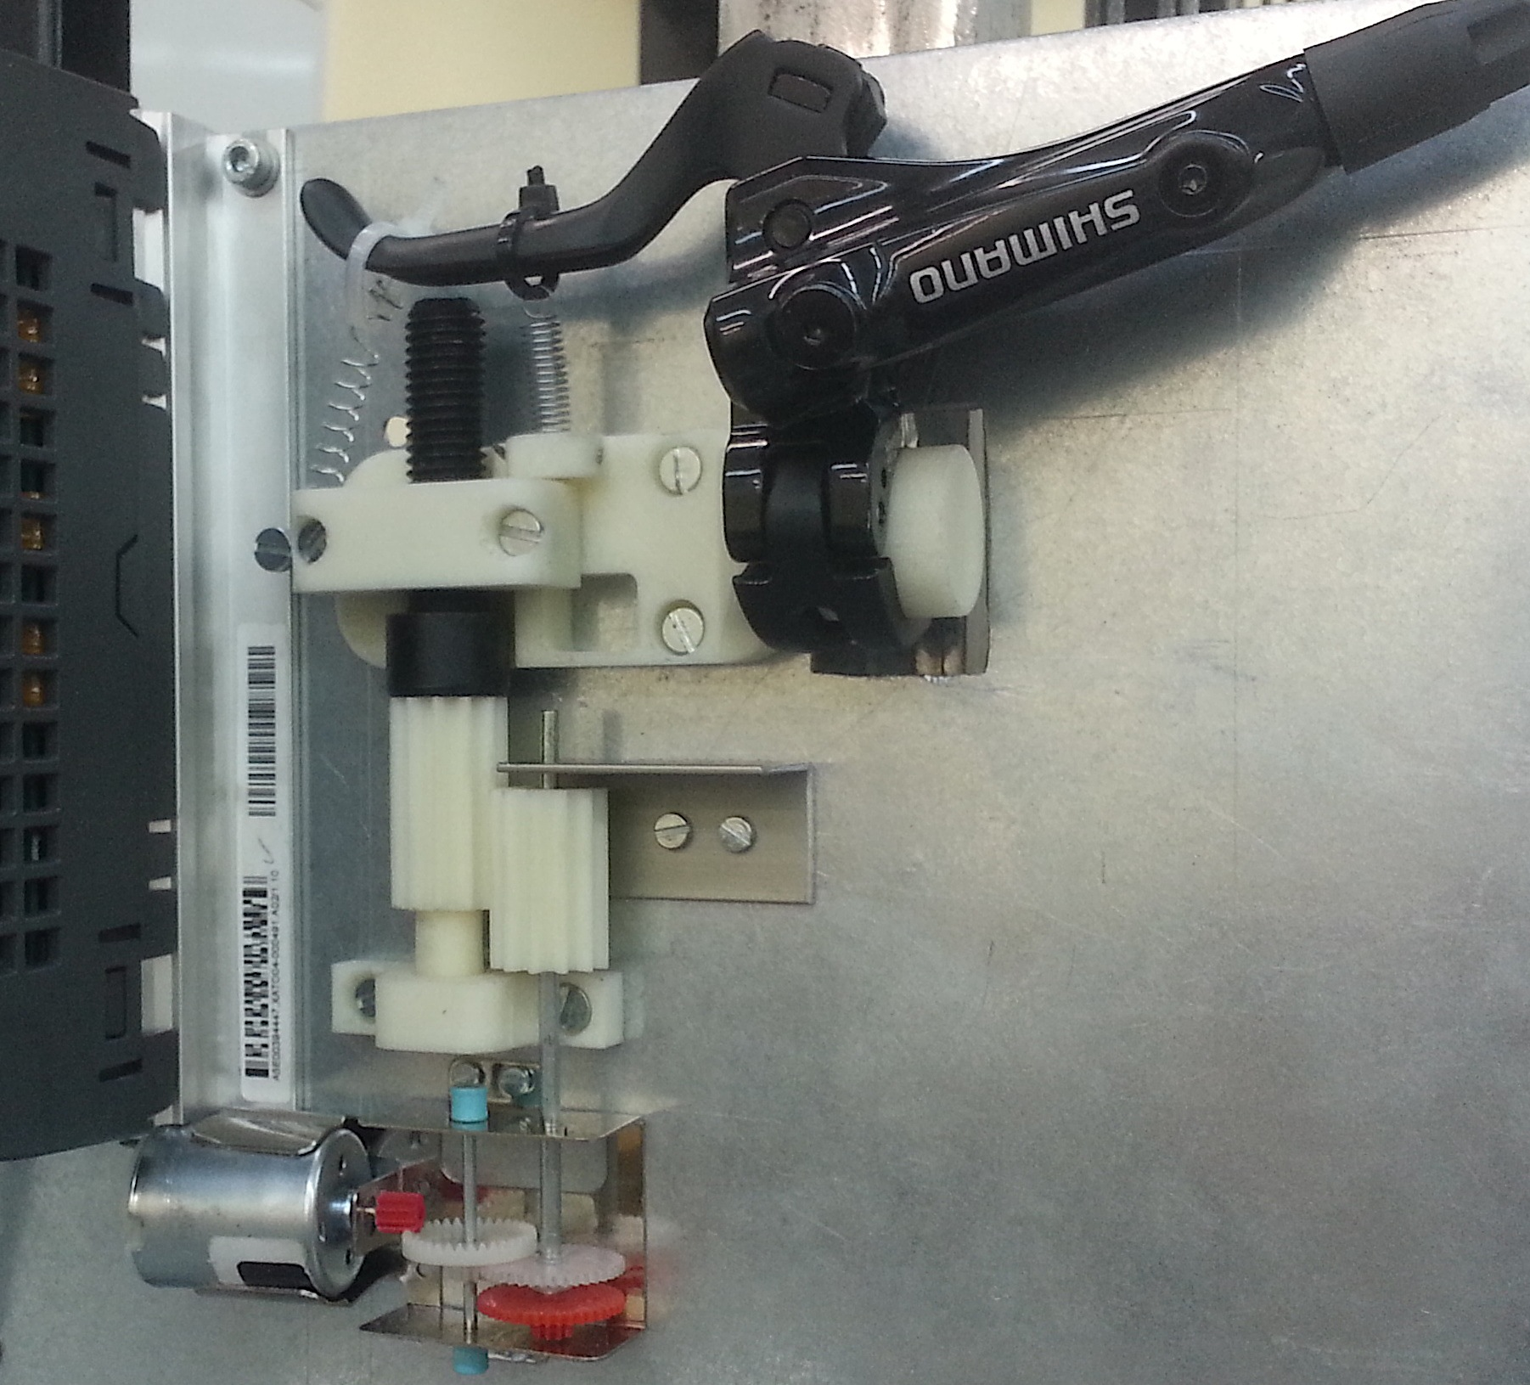
Figure 3: Brake system activation mechanism.

The engineering behind this mechanism came out of necessity for a reliable device to apply and reset the brake lever. The small motor at the bottom left of the figure was controlled electronically. Once activated the motor would turn the large black screw below the brake lever. This was achieved despite the relatively low torque of the motor, through a series of gears. To activate the brake system the black screw would move downwards. This allowed the brake lever to be pulled down by steel springs, therefore activating the brake callipers. To release the brakes the motor was simply reversed, moving the black screw upwards and in turn raising the brake lever.

This setup required fine-tuning in order to correctly set the brake activation point. In order to achieve a fast acting brake the black screw should not have to move a great distance. Once set correctly the brake proved to be reliable and consistent.

The figures below show the brake lever before and after activation:

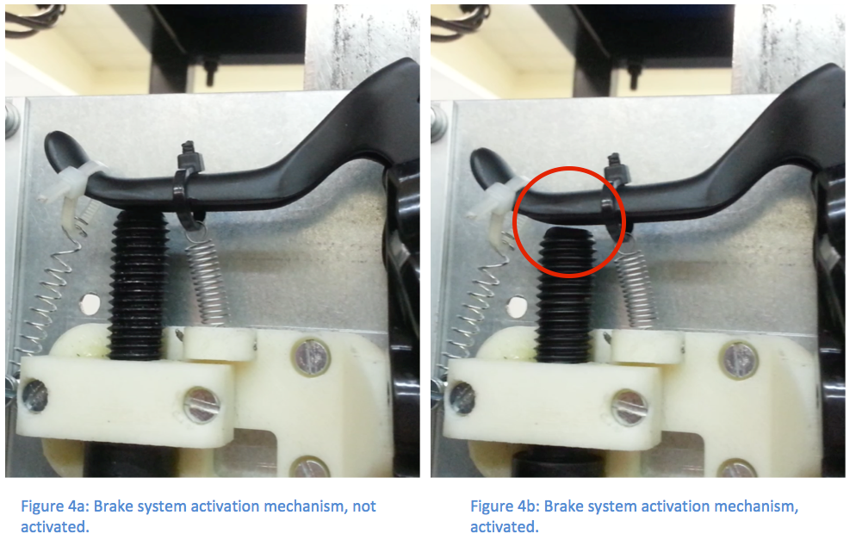

Although small, the difference between figures 4a and 4b can be seen in the area indicated by the red circle.

1.1.5 Cabin dimensions, maximum load and number of passengers

The European standards for design and installation provided the following requirements for passenger lifts:

“5.4.1 Height of car
The interior clear height of the car shall be at least 2 m.”

These standards did not contain many regulations specifically about the dimensions of the lift cabin. Accessibility standards were looked to for more information, this can be found in section 1.2.

The following regulations are given about the lift load:

“5.4.2.1 General case
To prevent overloading of the car by persons, the available area of the car shall be limited.
The car area shall be measured from wall to wall car body inner dimensions excluding finishes.”

The relationship between rated load and maximum available area, taken from the standards, is given in Table 2.

Table 2
Rated load and maximum available car area
Rated load,  mass  (kg) | Maximum available  car area  (m²) | Rated load,  mass  (kg) | Maximum available  car area  (m²)
100  180  225  300  375  400  450  525  600  630  675  750  800  825 | 0.37  0.58  0.70  0.90  1.10  1.17  1.30  1.45  1.60  1.66  1.75  1.90  2.00  2.05 | 900  975  1000  1050  1125  1200  1250  1275  1350  1425  1500  1600  2000  2500 | 2.20  2.35  2.40  2.50  2.65  2.80  2.90  2.95  3.10  3.25  3.40  3.56  4.20  5.00

The outer dimensions for the floor of the prototype cabin were chosen to be 0.2m by 0.25m (width and depth respectively) therefore the floor area could be found as 0.5m². As our prototype is a tenth scale, the floor area in reality would be 5m².
Assuming that our lift were to have thicker walls and furnishing the floor area would decrease; a value of 0.1m was taken for the width for 3 walls not including the full glass wall. This would decrease the floor plan width by 0.2m and the depth by 0.1m resulting in a decrease in floor area to 3.99m², or about 4m². The maximum rated load for our lift could then be interpolated using the following equation:

$$y_{2}=\frac{(x_{2}-x_{1})(y_{3}-y_{1})}{(x_{3}-x_{1})}+y_{1}$$

Where the maximum available car values (m²) of 3.56, 4 and 4.2 were X₁, X₂ and X₃ respectively; the rated loads (kg) 1600 and 2000 were Y₁ and Y₃ respectively; the unknown rated load was Y₂.

The rated load for the prototype elevator’s floor area (1:1 scale) was found to be 1875kg.

For the final physical prototype the rated load was chosen as 8kg. This was seen to be a manageable weight in order to effectively demonstrate the elevator mechanics and features.

1.2 Accessibility standards

Accessibility standards were sought in order to find more exact regulations on the cabin size, as well as other features necessary in real lifts. European standards for accessibility could not be easily obtained, however the Hong Kong government accessibility standards for lifts were freely available.

The following regulations are given for elevator cabin sizes:

“78. Special Requirements for Accessible Lifts

(1)

… A lift shall have minimum internal car dimensions of 1200 mm x 1100 mm wide, with a minimum clear entrance width of 850 mm, and shall have handrails extending to within 150 mm of the corners at the rear and sides of the car. The top of the gripping surface of the handrails shall be at a height of 850 mm – 950 mm, with a space of 30 mm - 50 mm between the handrails and wall.” [4]

The following figure provides an isometric view of an example accessible lift cabin:

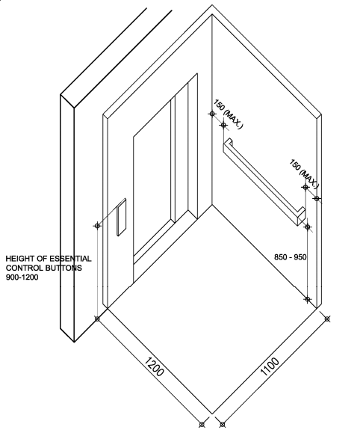
Figure 5: Accessible lift [4].

The following regulation is also given regarding cabin space.

“Wheelchair Turning Space

(e) An unobstructed wheelchair turning space of 1500 mm x 1500 mm should be provided in front of accessible lift car door.” [4]

In order to meet these regulations the size of the cabin for the cabin, the dimensions were chosen to be larger at the concept design stage. The equivalent exterior floor plan size was chosen as 2000 mm x 2500 mm. The height of the cabin was chosen as 2500 mm, 500 mm taller than the minimum dimension given in the European standards in section 1.16.
A handrail was also incorporated into the cabin at the concept design stage, according to the regulations mentioned previously. This is shown in the figure below:

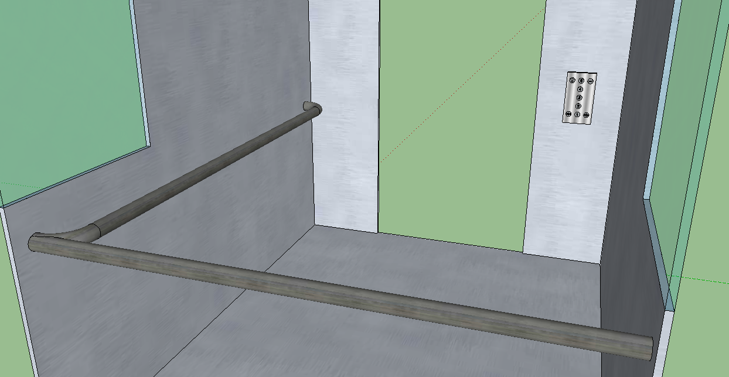
Figure 5: Guiderail and control panel positioning, concept design stage.

All relevant regulations regarding the interior lift control panel are given below:

“80. Lift Control Buttons

(1) Essential lift control buttons including floor numbering buttons, emergency alarm push button and door opening push button in the lift car shall not be less than 900 mm and not more than 1200 mm above the floor of the car.
…
(4) All lift control buttons shall have a minimum dimension of 20 mm…” [4]

Figure ?? shows the positioning of the internal control panel. The following figure shows an example control panel:

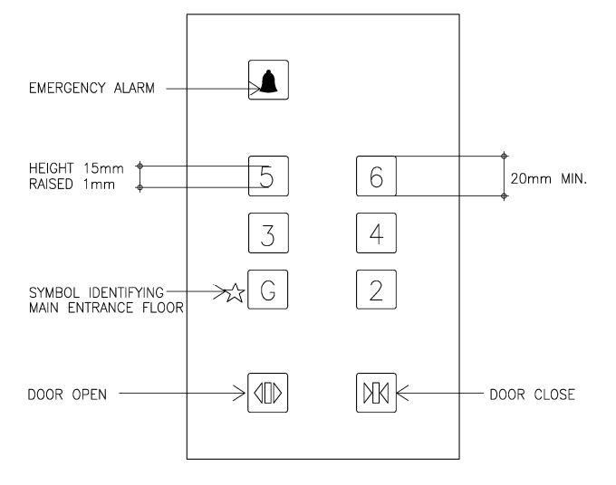
Figure 6: Tactile Graphic for Lift Control Buttons [4].

This control panel design was also closely followed during the concept design stage, as shown in the following figure:

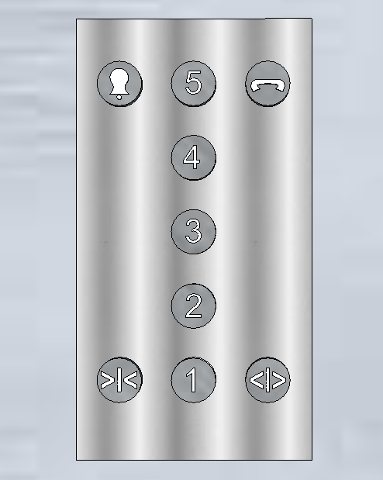

The accessibility standards were very useful in determining the overall layout of the lift cabin at the concept design stage as well as outlining what was legal or illegal. It was important to consult all the standards mentioned previously as, based on the specification of the lift delivered to the group by the client, it was important that safety was taken into consideration when creating the design.

